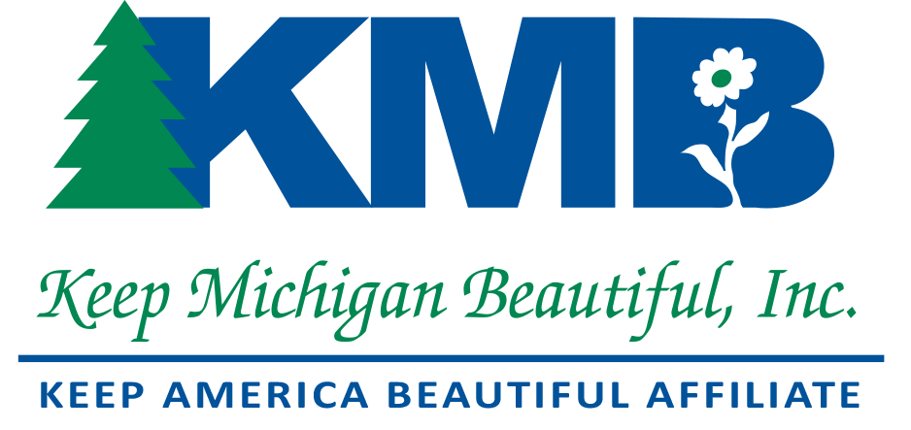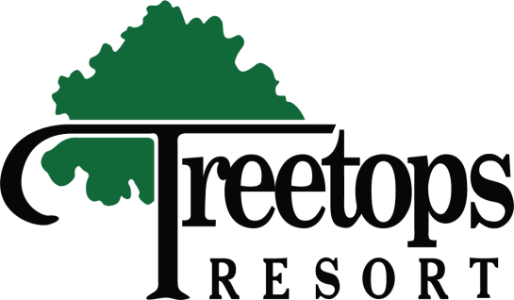

Summer Board Meeting
July 10th-11th, 2025
Treetops Resort
3962 Wilkinson Rd.
Gaylord, MI 49735

Suggested Activities for Thursday, July 10th
Arrival time:1:30pm-KMB is holding 10 rooms at total price of $127.96- Two double beds- Reservations must be made by June 18th to receive KMB rate. Call-989-732-6711 to make reservations. Check-in is at 4:00pm or earlier if rooms are available. No Saturday Check-Out (Lunch on your own)
- 3:30pm: Gaylord City Elk Park Viewing Area- Golden Elk Ct. –Free!
- 4:30pm:Tour the Call of the Wild Museum- Seniors-$8.00- Adults-$9.00
850 S. Wisconsin Ave. Gaylord, MI (989) 732-4336
- 6:30pm: Dinner gathering at the Sports Bar at hotel- (or on your own)

Friday, July 11th
*Breakfast on your own
10:00am- Registration
10:45am- Speaker- Gaylord Chamber of Commerce
11:30am- Break for Lunch- Legends Restaurant at Hotel (provided by KMB)
!2:45pm --2:00pm- KMB Board Meeting adjourned
__________________________________________________________________

We are excited to get together with our KMB family this summer in beautiful Gaylord, Michigan. We haven’t seen many of you in a while. This is a great time to re-connect, re-engage and re-energize KMB. Please RSVP to this email to confirm your attendance. Or call 313-268-3523. Looking forward to seeing everyone there!

